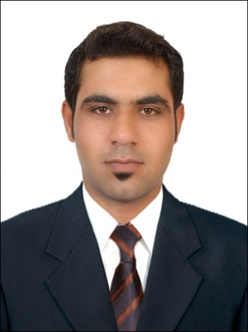**Guhram Muhammad Anwar**

**Mob: +971502571735**

**+923101234322 +923341110003**

**Email : guhram.m.a@gmail.com**

**Objective:**

Seeking for a challenging and reward winning position, where I can solve challenging issues through my communication and public relation skills. To achieve organizational goals in best and possible manner and attain career development through excellent performance with the goals.

**Experience:**

Feb`10-Aug`11 Ministry of Justice Abu Dhabi, UAE

**Driver cum Public Relation Officer (PRO)**

**.** Payments of traffic fines imposed on the vehicles.

**.** Keeping track of drivers and the vehicles so as to charge the right person

on traffic fines.

**.** Arrangement of Medical Insurance Cards to new employees and renewel

Of existing employees` cards.

**.** Occasional visits to the immigration for getting updates of the visa status.

**Education:**

2005-2007 Aptech Computer Training Institute Abu Dhabi, UAE

**.** Higher Secondary School Certificate (I.Com,2nd Div.)

**.** Major Courses: Accountancy, Economics, Computer Science, Business &

Marketing.

**Computer Skills:**

**.** A+

**.** Microsoft Office, Microsoft Excel & Microsoft Word.

**Bio Data:**

**.** Father`s Name : Muhammad Anwar

**.** Religion : Islam

**.** Nationality : Pakistani

**.** Marital Status : Single

**.** Driving License : UAE light vehicle

**.** Languages : Arabic, English, Farsi, Urdu & Balochi

**.** Visa Status : Tourist Visa