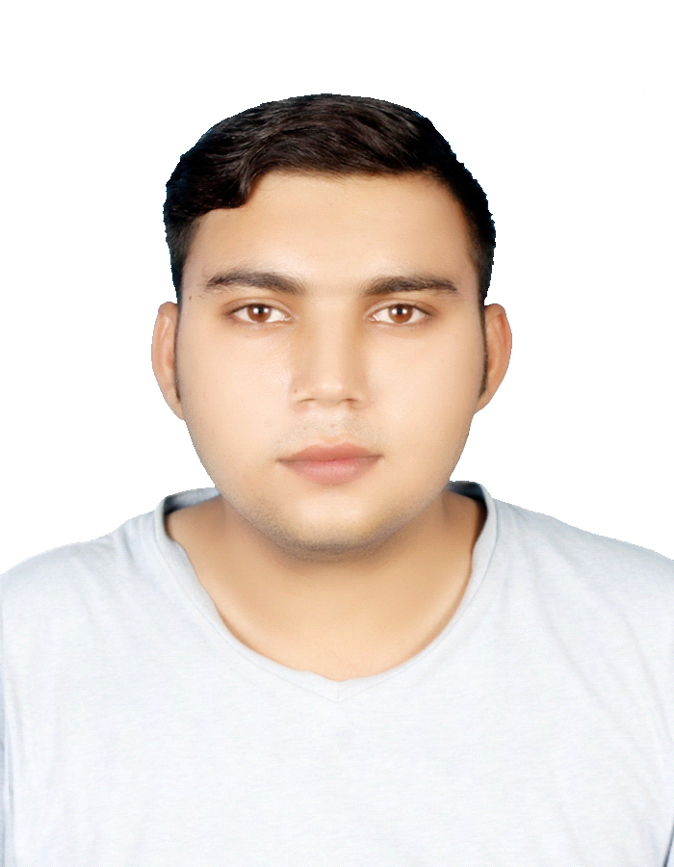
MAHAD RASHEED
Email: mahadrasheed293362@gmail.com
Contact: 00971589431941
Address: Al Humriya Palace Near BurJuman MS Bur Dubai

Career Objective:

To seek responsible and challenging job in your esteemed organization for a suitable post, where I will be able to apply my academic knowledge and work experience.

Personal Skills:

- Good Command of computer (MS-office)
- Good Command of computer (MS-Excel)
- Good Command in outlook
- Ability to communicate effectively
- Ability to work extra hours
- Possessing leadership abilities
- Worked for various promotional jobs.

Qualification:

- SSC Board of Intermediate and Secondary Education in Multan, Pakistan.
Attained a percentage in Matriculation "70%"

- Diploma Introduction to Computing (6 months)
Virtual University of Pakistan, Jalal Pur Pir wala Campus
HTML , CSS , Adobe Photoshop Attained a percentage of "68%”
Grade “D”

Diploma in Financial Accounting (6 months)
Virtual University of Pakistan, Jalal Pur Pir Wala.
Attained a Percentage in Diploma "70%"

Personal Strength:

- Hard working
- Dynamic, energetic, self-motivated and dedicated
- Quick learner
- Ability to act as willing Team player and to work in tens environment
- Dedicated and self- Motivated approach to the job

Working Experience:

- 6 Months Experience of Junnior Accountant In ASNB Real Estate L.L.C Dubai
- 1 Year Experience as a Data Entry Oprater in Shabir Cotton Factroy Multan Pakistan
- 1 Year Experience as a Marketing And Sales Supervisor in P&G

Personal Profile:

Name: Mahad Rasheed
Father's Name: Abdul Rasheed
Date of Birth: 15 Aug1996
Place of Birth: Multan, Pakistan
CNIC No. 36301-8543051-9
Marital Status: Single
Religion: Muslim
Nationality: Pakistani
Sex: Male
Passport No: fb9840511
Date of Expiry: 28Dec2019

Language Known as Read, Write, Speak and Type:

- Urdu, Hindi, English, fluently can speak, read, write and type.
- Arabic fluently can speak, read and write.

