**CURRICULUM VITAE**

**ROHIT BISHT**  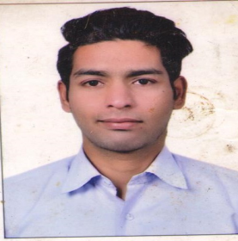

Location: Dubai

Mob. No. +971569852948

Email id:-rohitbisht7915@gmail.com

**CAREER OBJECTIVE: -**

Seeking a responsible position in the organization, which will give me chance to enhance my knowledge and enable me to strive towards the overall development of the organization.

**ACADEMIC QUALIFICATION:-**

* 10th Passed from CBSE Board in 2009.
* 12th Passed from CBSE Board in 2013.
* B.A. Passed from Delhi University 2016.

**PROFESSIONAL QUALIFICATION:-**

* One Year diploma of computer course from The Delhi Institute Of Computer Science 2010-11.
* One Year diploma in hotel management & tourism from Uttaranchal institute of Hotel management & tourism in 2011-12.

**WORKING EXPERIENCE:-**

1 Year worked with Big Cinema as a Operation Associates. 2013-14

6 Months worked in D.T. Cinema as a Team Member cum Store Keeper. 2014

1 year worked in Smaaash Noida as a Sr.Waiter. 2016-17

1 year worked in striker sky Bar Golf Course Road Gurgaon HARYANA as a Sr.Waiter. 2018-19

1Year 2 months work with where we met (big Wong) Noida restaurant organization. as a captain responsible for day to day inventory management.Taking care of supply management

Indenting weekly & Doing all reporting related to restaurant. 2019-20

**STRENGTH:-**

* Positive Learning Attitude & Ability to keep cool in Stress hours.
* Believe in Team Sprit and Hard Working.

**PASSPORT DETAILS:-**

Passport No. :- R2666617

Date of Issue :- 04/09/2017

Expire Date :- 03/09/2027

Visa Status :- Visit Visa

**PERSONAL DETAILS:**

Father Name :- Mr. S.S Bisht

Date of Birth: :- 05 April 1994

Gender :- Male

Nationality :- Indian

Marital Status :- Unmarried

Language Known :-Hindi & English

**PLACE:**

**DATE: ROHIT BISHT**