resume
WAITER


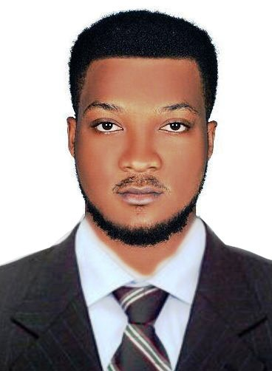
IDENTIFICATION
Names |  | FAHDEEN MICHAEL JUNIOR
Contact |  | +971 0506439740
Email |  | fahdeenm@yahoo.com
Duty required |  | WAITER
Languages  Experience |  | Fluent in ENGLISH and FRENCH  2year 2months
Availability |  | Immediately
Date of Birth |  | 17 September 1996

Personal Profile Statement/ Career Objectives
I am a very confident, trustworthy and conscientious as a WAITER inclined person who is able to multi-task, handle pressure, work as part of a team or individually. I am passionate and I am self inspirational towards work. With the extensive experience I have had as a WAITER I have developed superb organizational, and problem solving skills.
I am currently looking for a suitable WAITER opportunity which will not only challenge me professionally but also allow me to develop my knowledge & potential further. I love being a small but important part of a bigger picture.
Areas Of Expertise

- English and French communication skills and experience liaising effectively at all levels.
- Strengths in multi-tasking and the ability to respond to dynamic working conditions.
- Strong customer service skills, including assessing customer needs, adhering to quality standards, evaluating customer satisfaction, and making the proper adjustments or corrections.Excellent active listening skills and ability to give my complete attention to patrons during busy times.Demonstrated service orientation,always looking for opportunities to serve patrons and assist other employees.Patient and compassionate when serving patrons, making them feel at home at the establishment in which they are eating.Solid background in organizing other wait staff and hosts, coordinating my responsibilities to ensure a smooth flow of service.
- Highly developed problem solving, interpersonal and team work skills.
- Highly motivated and goal oriented.

Career History

Hôtel Résidence La Falaise,Cameroon.(4star)

WAITER From feb. 2015 to apr. 2017

Duties:
- Take orders from and serve food and beverages to patrons.
- Perform consistent check-ins with patrons to ensure satisfaction and address complaints swiftly.
- Answer questions about the menu and make recommendations when appropriate or requested.
- Prepare appetizers, salads, and cold dishes.
- Assist a team of hosts and hostesses by greeting, seating, and thanking customers
- Communicate with kitchen staff directly and via computers
- Cleaned tables, removed dirty dishes, and replaced table linen
- Replenished clean linens, glassware, silverware, and dishes
- Supplied service staff with food
- Served patrons with water, coffee, and condiments.
- Stocked refrigerators with bottled beer and wines.
- Cleaned and polished furniture, shelves, walls, and equipment
Education
HOSPITALITY MANAGEMENT CERTIFICATE 2016

MOUNTAINIA HIGHER INSTITUTE OF IT
Diploma Computer Maintenance and Networking 2014-2015

GHS BOKWANGO BUAE (High School)
G.C.E ADVANCE LEVEL Certificate 2014

Additional Skills
Operational Knowledge of:
- Computer Maintenance
- Microsoft office (Word, Excel, Power point, Publisher).
- Internet.

Hobbies
- Reading, Research,Sport,Innovation in tech

