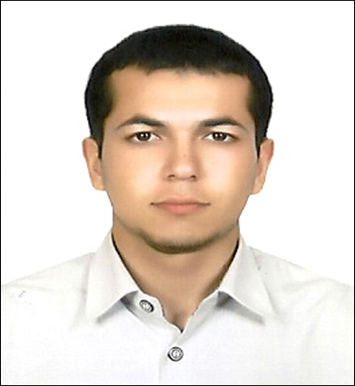
GURBAN HUDAYBERDIYEV
Email: kurbanchik@yahoo.com
Mobile: 054-5684717
Visa status: Employment Visa

OBJECTIVE
Having identified my potential would like to contribute to the growth of an organization which is able to use my outgoing personality and creative skills and offer me a challenging position in the field of Customer Services and Sales. Seeking an innovative atmosphere where my knowledge and experience can be shared and enriched looking for an opportunity where I can apply knowledge gained to meet the demands and challenges in real life situations. To achieve the goals set by my seniors / management. Very cooperative and get along with people at all levels. I am also quick to appraise new situation and learn new assignments with excellent communication skills.

SUMMARY OF QUALIFICATION:
- Holding a valid UAE DRIVING LICENSE/ LIGHT VEHICLE
- Hard working
- Basic Knowledge in Computer Application
- Flexible and Fast learner
- With Good English Speaking
- Graduate of “CALICAT” English Course

WORK EXPERIENCE:
Organisation: Levee Restaurant & Café
Period: December 2017- to present
Position: Head Waiter

Responsibilities:

- Evaluated performance of all waiters and prepared reports for management.
- Communicated with guests on regular basis and ensured that they are satisfied.
- Identified all demanding guests and informed restaurant manager for the same.
- Served all food and beverage as per hotel standards and within the required time.
- Provided all customers efficient service at all times and cooperated with staff members for same.
- Provided quality training as per the required service standards.

Organisation: |  | Saladicious, Dubai, UAE
Period: |  | November 2013 till present
Position: |  | Waiter
Responsibilities:
- Serves food and beverage to guest according to operating procedures and general rules of table service etiquette. Performs various incidental duties to increase guest’s enjoyment and facilitate a smooth overall operation of the dining room
- Sets up assigned station and serving station
- Inspects all items that are to be used for cleanliness and appearance
- Inspects areas to ensure that tables have been reset properly, all tables, chairs and under table areas have cleaned after bussing, and all supplies have been replenished
- Maintains all service stations in excellent condition
- Delivers the order promptly and inspects all items before serving for appearance, temperature correctness
- Assist in bussing table as necessary
- Correctly completes all guests checks and accounts for issued check
- Coordinates and cooperates with all restaurant staff, including cooks, bus attendants, other waitress, cashier and Manager
Organisation: |  | Yimpash Turkish Company, Ashkhabat/Turkmenistan
Period: |  | October 2011 – March 2013
Position: |  | Sales Executive
Responsibilities:
- Responsible for arrangement of showroom display
- Merchandising old and next collections according to high standards
- Monitoring stock control, suggesting price revision action on the basis of sales and customers feedback
- Selecting items for new collection
- In-charge of promo items sales and keep daily sales report
- Display available stocks according to the company standard
- Promoting the quality of the products

Organisation: |  | Altyn Asyr Mall, Ashkhabat/Turkmenistan
Period: |  | August 2010 – May 2011
Position: |  | Salesman
Responsibilities:
- Mainly dealing in men’s fashion
- Responsible for products marketing
- Promotions of products
- To build a pleasant friendly relationship with customer
- Daily sales report writing and recording
- To prepare weekly and monthly plans
- Changing of display
- Dealing with new clients
- Ensure smooth and efficient servicing to the customers

EDUCATION BACKGROUND:
- TERTIARY: Course Centre “Calicat” English Course S/Y 2010 - 2011

- SECONDARY: ASKHABAT HIGH SCHOOL S/Y 2000- 2010

PERSONAL INFORMATION
- Nationality : Turkmen
- Religion : Muslim
- Languages Known : English, Russian, Turkish&Turkmen
- Marital Status : Single
- Date of Birth : May 3rd 1993

