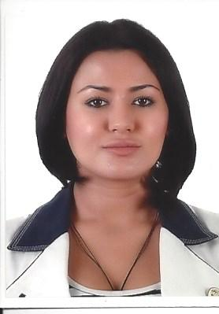 **Curriculum Vitae**

**SHIRIN IBRAGIMOVA**

Maktoum Street, Dubai, UAE

[Ibragimova_shirin@hotmail.com](mailto:Ibragimova_shirin@hotmail.com)

**971501858606**

**Objective:**

Desire a position as Cosmetics Sales Representative in a reputable company, putting to use unsurpassed record of sales and promotions experience, networking and negation skills to assure best deals for organization where I can apply my knowledge of converting prospective leads into sales.

**Qualification Summary:**

Hardworking sales representative possesses experience in UAE and outside GCC countries in sales of Fragrance and Cosmetics’ industries. Known for having strong ability to convince customers towards optimal sales, through high level of determination, positive attitude and build up career in selling world-class brand names in cosmetic industry with potential sales.

* + Outstanding interpersonal skills.
  + Backed by the world-class resources and products with ongoing sales.
  + Ability to succeed in a competitive environment.
  + Strong Communication Skills.
  + Career-oriented, strong organizational and territorial management skills.
  + Self-starter attitude.
  + Excellent work ethic prior selling experience.

**Notable** **Skills** and **Competencies** **include**:

* Energetic, Friendly, Pleasant, Outgoing, Result-Oriented, Enthusiastic, Good Written and Verbal communication.
* Proficient in presentation, writing and editing manuals of product promotion and advertising.
* Exceptional customer service.
* Proven attitude in problem solving.
* Can operate independently and as part of the team.

**Work Experience:**

**Company:** Grandstores LLC

**Position:** Beauty Advisor (Dedicated staff to Christian Dior)

**Joining Date:** March 19, 2015- September 22, 2015

**Job Description:**

* + - Selling the products which are assigned to me (Dior).
    - Merchandising
    - Ordering and Stock replenishment.
    - Maintaining Dior Counter’s cleanliness.
    - Stock Inventory.

**Company:** Saj LLC

**Position:** Cosmetic and Fragrance Sales Specialists

**Joining Date:** 2010-2012

**Job Description:**

* Experience in customer makeovers
* Have a strong working knowledge of cosmetics & fragrances
* Possess a professional demeanor
* Instinctive belief that customer service is job number one
* Responsible for delivering a friendly service, smiling, greeting and making eye contact.
* With every customer that comes to the store.
* Playing an active role in providing a
* Positive customer experience and driving sales.

**Duties**

* Provided a Friendly and helpful service to customers
* Maintaining high standards of presentation and cleanliness across the store
* Demonstrated excellent product knowledge to customers on key promotions and offers.
* Carrying out stock replenishment.
* Able to easily build a rapport with customers.
* Have ‘fit’ measurement experience
* Good people skills and able to work as part of a team.
* Strong individual skills.

**Education:** High School

**Birth of Date:** October 19, 1986

**Status:**  Single

**Visa Status:** Tourist Visa

**Nationality:** Uzbek

**Trainings Attended:**

* **Dior Trainings** - Introduction

-Fragrance, Skin Care and Make-Up

- Novelties

-Make-up artist training

**Languages Known:**

Uzbek Fluent Mother Tongue, Reading, Writing, and Speaking

Russian Fluent Reading, Writing and Speaking

English Fluent Reading, Writing and Speaking