CURRICULUM VITAE
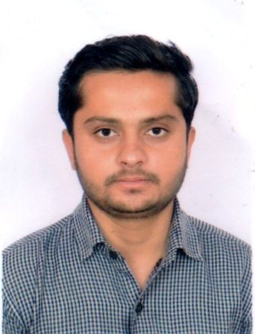

ZUBAIR SAIFI

28, Ahmad Nagar,

Delhi Bypass Road ,
Jaipur (Rajasthan)
Mobile No. + 91-9887233528
Email :- zubersaif717@gmail.com

CAREER OBJECTIVE

To work in a challenging atmosphere, which provides an opportunity for learning and growth within a management environment continues efforts, towards development and success of the company.

EDUCATIONAL QUALIFICATION.

- Passed Secondary from Rajasthan Board .
- Passed Senior Secondary from Rajasthan Board .
- Passed B.B.A from Rajasthan University in Jaipur.
- Passed M.B.A(Human Resource & Finance) from Rajasthan Technical University in Kota .
- M.Com (E.A.F.M) from Rajasthan University.

COMPUTER KNOWLEDGE
- Basic Information
    - Computer fundamentals
    - Windows Vista/ XP
    - MS Word 2007
    - MS Excel 2007
    - MS Power Point 2007
    - Internet
    - Outlook Express.

- Tally ERP 9 (Enterprise Resource Planning)

HOBBIES:

. Playing Billiards and chess.

Work Expericence

- Worked in Hotel Bliss as a Manager for few Months

PERSONAL DETAILS

Father’s Name : Mr. Mohammed Ishtyak Saifi
Gender : Male
Date of Birth : Aug. 28th 1993
Marital Status : Un-Married
Languages known : English & Hindi ,Urdu
Nationality : Indian
Religion : Muslim

DECLARACTION
I hereby declare that the information furnished here in is correct to the best of my knowledge and belief.

DATE:-

PLACE

(ZUBAIR SAIFI)

