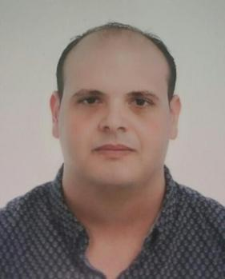**Khoubeib mezrioui**

**Marital status: single**

**Nationality: Tunisian**

**Date and place of birth: 05/07/1986 Tunisia**

**Mobile phone in Dubai: 00971 55 867 7386**

**Email: [*](mailto:khobiko_von_525@yahoo.fr) khobiko_von_525@yahoo.fr**

**Current location : Dubai**

**WORK EXPERIENCE**

HOMIES BURGER AND PASTA - khawaneej city - Dubai

1 year

* Mar.16-mar.17 waiter
* Check with customers to ensure that they are enjoying their meala /present menue to the customers and answer questions about menu items making recommendations upon request and present food or beverage information or menu to customers /escorts customers to their table and assist him with seating arrangements /prepare tables for meals including setting up items such as linens silverware and glassware
* Suggest to the customers the menu of the day or chef s dish

**Daynamic hospitality group --- LA POSTRERIA RESTAURANT --DUBAI MARINA JBR**

**2 years**  waiter and barista

* Mar.14-mar.16
* Serve alcoholic and no alcoholic beverage in conjunction / ensure knowledge of menu and all product /ensure mise en place is well stocked at all floor station /Answer questions on menu selections /collect payments from customers
* Check with customers to ensure that they are enjoying their meals and take action to correct any problem /prepare checks that itemize and total meal costs sales tax

ULYSS -HYPER- DISTRIBUTION -- CARREFOUR MARKET TUNISIA

**3 years Sales AND SUPERISOR (BUTCHERY AND FRYER SECTION)**

**NOV.11--MAR.14**

* Sharpen and adjust cutting equipment ,receive inspect and store meat upon delivery ,cut ,bone ,or grind pieces of meat -weight,wrap and display cut of meat -cut or prepare meats to specification or customers ordres- store meats in refrigerations or freezers at the required temperature -keep inventary of meat sales and order -clean equipment and work areas to maintain health and sanitation standars

**EDUCATION**

**2008-2011(3 years)**: **Higher Institute of Tourisme Sousse-tunisia Section**: **catering management Graduation: Advanced technician's certificate**

**2006-2008 (2 years) : hotel school sousse- tunisia Section: « cooking** » **Graduation  : Vocational technician's certificate**

**Level of academic study: bachelor level economics and management**

**Career Objectives:**

**To obtain a long-term career with an organization which has a strong background that provides goods opportunity for enhancement of professional and personal status**

* **UAE driving licence light vehicle available**

***SPECIFIC SKILLS:***

French  : write and speaker good English : average Arabic : native speaker

***Computer knowledge:*** Word, Excel, internet, power point

***Hobbies:***  Sport, music, fishing, kitchen, internet

**Personal Strength:**

* **Good Leadership with team work, Very Co-operative, Quick learner and Smart worker.**
* **Self-Motivated, Enthusiastic have direction plan and control to meet challenges.**
* **Flexible, energetic, patient and able to work in a multi-cultural Environment**