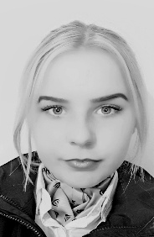 Roberta Sotnikovaite

**Address:** 2 Scarna Court, Emyvale, Co. Monaghan, Ireland

**Email:** [sotnikovaite_r@yahoo.com](mailto:sotnikovaite_r@yahoo.com)

**Mobile No. :** +353 871040929

**Date of birth:** 28.09.1998

**Languages**

English- Fluent, Lithuanian- Native, Russian- Moderate

**Education**

Tourism and Travel with Business QQI Level 5, Monaghan Institute, Ireland 2015 – 2016 St. Louis Secondary School Monaghan 2011 – 2016

Certificate in gel nail extensions, manicure and pedicure

**Work Experience**

**Castle Leslie Estate 4*, Food and Beverage Assistant** Sep 2019 – Present

Glaslough, Co. Monaghan, Ireland

* Take orders from customers
* Make hot beverages
* Make alcoholic drinks
* Good attention to detail
* Multi tasking
* Good presentation
* Trained

**Ryanair, Cabin Crew** Feb 2018 – Aug 2018

Belfast International Airport, Northern Ireland

* Complete security checks on aircraft
* Knowledge of how to perform medical and safety procedures in an emergency
* Serve customers and sell products on-board
* Flexible schedule

**Silver Hill Farm, General Operative**  Oct 2016 – Jul 2017

Emyvale, Co. Monaghan, Ireland

* Cut duck on the line
* Weigh and package
* Make sure the whole area is clean and sanitised
* Clean and sanitise machinery
* Lift, push and pull heavy objects