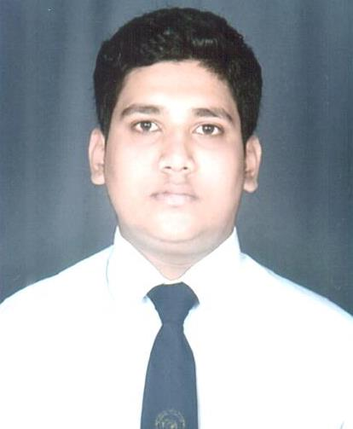**MAK MUZ**

Mobile: +971588457147/+971581252570

E-mail: makmuz2101@gmail.com

**OBJECTIVE**

* To scale new heights with better performance and guidance.
* Looking for an exhilarating career in an organisation of immense repute, which demands the best of my professional ability in terms of excellence, analytical organisation and communication skills, and helps me in broadening and enhancing my current skills and knowledge.

**OVERVIEW**

* Building guest preference & driving volumes; identifying & developing new streams for revenue growth and maintaining relationship with channel partners, to achieve referral business.

**Job Description:**

**During Industrial Exposure Training:**

* As a beginner in the industry, learnt the procedures & formalities of a hotel.
* Learnt the basic hospitality operations in all the departments of a hotel. Cross trained in F&B service, Food Production, Housekeeping & Front Office
* Learnt about Guest Request & ways to achieve the same

**Roles and Responsibilities:**

• Greet and escort customers to their tables

• Present menu and provide detailed information when asked (e.g. about portions, ingredients or potential food allergies)

• Prepare tables by setting up linens, silverware and glasses

• Inform customers about the day’s specials

• Offer menu recommendations upon request

• Up-sell additional products when appropriate

• Take accurate food and drinks orders, using a POS ordering software,order  slips or by memorization

• Check customers’ IDs to ensure they meet minimum age requirements for consumption of alcoholic beverages

• Communicate order details to the Kitchen Staff

• Serve food and drink orders

• Check dishes and kitchenware for cleanliness and presentation and report any problems

• Arrange table settings and maintain a tidy dining area

• Deliver checks and collect bill payments

**Working Experience:**

**. Jabel ali Resorts & Hotels (Dubai)**

Our journey, which led to us becoming an international hospitality company known for its unique collection of properties, started in 1981 with the formation of Dutco Hotels. Named after our parent company which was established in 1947, the new company owned and operated the Arabian Gulf’s first two resort properties in Dubai: JA Jebel Ali Hotel and JA Hatta Fort Hotel & JA oasis baech tower and JA ocean view hotel.

Position – Food & Beverage Associate.

From- 24-07-2018 Until- Present.

**. Arabian Park Hotel (Dubai)**

Arabian Park Hotel and Park Hotel Apartments are hospitality members of the illustrious Wafi Group owned by MKM Commercial Holdings in Dubai, best known for their Egyptian-themed shopping and entertainment complex - Wafi Mall.The Wafi Group was founded in 1973 and has since grown to include a host of world-class property management services, hospitality, manufacturing, transportation and services companies. The Group has earned both local and global recognition over the years for its exceedingly high standards of service.

Position – Food & Beverage Associate.

From- 17-10-2017 Until 06-07-2018.

**.Central Point Catering Services L.L.C (Dubai)**

Central point catering services is the banquet services which provides all the outing parties for guest and employers with high quality of service..

Position – Banquet waiter

From – 23-11-2016 Until 23-09-2017.

**STRENGTH**

* Dedicated, resourceful & decisive individual.
* Highly developed interpersonal skills.
* Self motivated & goal oriented.
* Functioning well in high stress atmosphere.
* Excellent work ethics.

**Educational Qualification:**

|  |  |  |
| --- | --- | --- |
| **Course** | **Duration** | **Institution** |
| Diploma in Hotel Management & Catering Technology. | **2015-2016** | Institute of Hotel Management and Catering Technology, Goa, India |

**Others details**:

Languages known : English, Hindi.

Computer skills : Micros & menu typing.

Nationality : Indian.