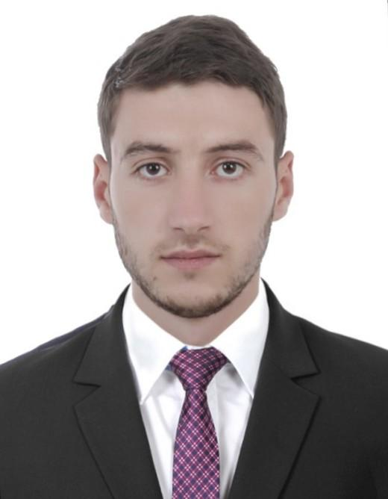**Mr Essam Kebaili**

**Street Address :**UAE - Dubai – Al Barsha Highest ( TECOM )

**WhatsApp :** (+971) 0566 60 57 91

**Phone Number : (+971) 0564 64 97 49**

**Email Address :** essamkebaili@gmail.com

**Date of birth :** 02 -09- 1994

**Nationality :** Algeria

**Visa Status : Resident** .

**Qualifications Summary**

Seeking for a challenge career opportunity to prove my skills by contributing continuously toward the development of the company and to utilise every opportunity to evolve in both professional and personal.

I Enjoy working in hospitality environment as this gives me the opportunity to interact with different people every day.It would be an honour to be part of your corporate family.

**Professional Experience**

* Waiter

Gourmet Grove Restaurant

Hessa St , Al Barsha Highest ( TECOM ) , Dubai 2018/(07) Months Experience

* Present menus to patrons and answer questions about menu items, making recommendations upon request.
* Prepare tables for meals, including setting up items such as linens, silverware, and glassware.
* Take orders from patrons for food or beverages
* Write patrons' food orders on order slips, memorize orders, or enter orders into computers for transmittal to kitchen staff
* Serve food or beverages to patrons, and prepare or serve specialty dishes at tables as required
* Check with customers to ensure that they are enjoying their meals and take action to correct any problems.
* Collect payments from customers
* Reception and administration

Hôtel Azdif / Resto (4*)

RueAbraneRamdane, Setif ,Algeria. 2016/2017 (01) year Experience

* Meeting & greeting clients/customers in a warm, friendly manner
* Be the first and last point of contact for our members and their guests
* Manage keys and badges (activation/ deactivation) for members
* Handle all daily incoming and outgoing mail for members
* Manage member check-ins and departures
* Support members with local area knowledge – restaurants, bars, events etc…
* Welcome all our members and meeting room guests with an authentic enthusiasm and smile in an informal
* Monitor the meeting room agenda and act as a host for the Business Club and events
* Answer all incoming questions and requests via phone, email or at reception
* Support the Resto/Hotel members with tasks varying from print jobs, ordering office supplies to booking a restaurant
* Responsible for opening the centre in the morning and closing the centre at the end of the day
* Act as back up for the Community Manager and General Manager/ Area Manager for all kinds of administrative tasks
* Support Community Manager and General Manager/ Area Manager with event planning and hosting
* Conduct tours for prospective customers
* Help the Resto/Hotel with my ideas on how we can keep improving our services
* Provide an outstanding guest experience
* Maintain an orderly front desk
* Operate computer programs and multi-line phone systems
* Maintain guest records and book reservations
* Complete basic cashier and bookkeeping responsibilities
* Contact necessary staff to solve problems when challenges arise, ensuring guest comfort.
* Watching live video (cctv) surveillance footage, reporting incidents or suspicious behaviour .
* VIP Waiter

Hôtel Azdif / Resto (4*)

Rue Abrane Ramdane, Setif , Algeria 2014/2016 (02) year’s Experience

* Welcome VIP guests to the organizational and also bid them good bye when clients are leaving
* Deal with complaints made by clients in efficient manner
* Ensure VIP clients enjoy themselves throughout their stay within the premises
* Inform VIP guests about details of the services provided
* Act as escort for VIP clients to and from their seats
* Get adequately informed about facilities in the organization
* Liaise with the supervisor, and also provide the later with detailed report about events and activities
* Keep clients happy all through their stay to ensure they come back for more patronage
* Provide clients with rather personal attention to ensure they have the best of the amenities and satisfactions the organization has to offer.
* Photographer **:**

Freelancer Since / 2011

Algeria**.**

* Market and advertise services to attract clients
* Analyze and decide how to compose a subject
* Use various photographic techniques and equipment
* Capture subjects in commercial-quality photographs
* Enhance the subject’s appearance with natural or artificial light
* Use photo enhancing software
* Maintain a digital portfolio, often on a website, to demonstrate work

**Volunteer Work**

First Aid Volunteer **:**

CivilProtection

Sétif, Algeria 6 months( Including 21 Day Training )2014/2015

Provide immediate, lifesaving, medical care before the arrival of further medical help. This could include performing procedures such as:

* Placing an unconscious casualty into the recovery position
* Performing Cardiopulmonary resuscitation (CPR)
* Using an automated external defibrillator (AED)
* Stopping bleeding using pressure and elevation
* Keeping a fractured limb still

**Educational Background & Certificate**

* **High School Degree /** Merzougi allawa Hight school

Sétif , Algeria **2012/2013** Diplomat in**: Experimental Sciences**

* **Photographer Training (Beginner) /** YouthandSportsDirectorate

Sétif **,** Algeria**. 2016/** (06) Months Training

* Understand the technical functions of Camera..
* Know the basic elements of digital photography.
* Gain a better understanding through practical exercises.
* Introduction to Digital Photography
* The Exposure Triangle – shutter speed, aperture.
* Camera Lenses – types, parts and purpose.

**Language**

**Arabic** (motherlanguage) **English** ( excellent ) **French** (excellent)

**Skills**

* Very good Computer knowledge : Word - Excel ...
* Flexibility , can do attitude , able to learn
* Confident , Self Motivated , Creative , Patient
* Team work , building connection’s
* Learn fast
* Accept the movement