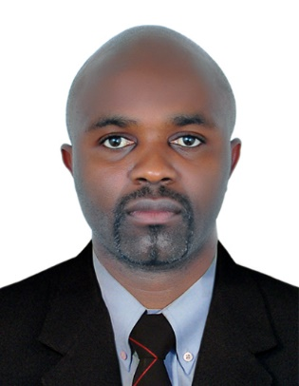

|  |  |
| --- | --- |
| **CURRICULUM VITAE** | |
| **PERSONAL INFORMATION**  Name: ANGU SOLOMON ANYE   |  |  | | --- | --- | | Nationality: | Cameroonian | | Address: | Dubai | | Birth date: | 10/02/1984 | | Gender: | Male | | Marital Status: | Married | |  |  |   Mobile: 0589945237  Email: angusolo@yahoo.com  **Waiter**  **CAREER OBJECTIVE**   |  | | --- | | Seeking a challenging position as a waiter in a company where I will be able to showcase my professional competencies, capabilities and experience. |   **VISION:**  To increase the shareholder’s value and maximize profit by improving the operational efficiencies and maximum utilization for the available resources.  **KEYS FOR SUCCESS:**   * Good organizational and planning skills. * Ability to work under pressure. * Flexibility to respond to a range of various work situations * High level of commercial awareness and cost control capabilities * Excellent leadership, interpersonal and communication skills * Committed to delivering high levels of customer service |  |
|  |

|  |  |  |  |  |  |  |  |  |  |  |  |  |
| --- | --- | --- | --- | --- | --- | --- | --- | --- | --- | --- | --- | --- |
| **PROFESSIONAL EXPERIENCE**   * **Azam Hotel as Waiter** Bamenda-Cameroon: 2015 To 2017 * **Ayaba Hotel as Waiter** Cameroon;   2014–2015 * Greeting customers. * Offering and serving beverages and appetizers * Taking and serving meal orders. * Continued service. * Delivering the check and accepting payment. * Insure housekeeping in the Restaurant * Clean tables or counters after patrons have finished dining. * Clean food service areas. * Arrange tables or dining areas. * Present food or beverage information or menus to customers. * Remove dishes and glasses from tables or counters, take them to kitchen for cleaning. * Assist host or hostess by answering phones to take reservations or to-go orders, and by greeting, seating, and thanking guests. * Schedule dining reservations and assist customers with seating arrangements.   **EDUCATION**  **Bachelors Degree**  **Advance Level**  **Ordinary Level**  **LANGUAGES**   | **Language** | **Level** |  |  | | --- | --- | --- | --- | |  |  |  |  | | English  French | Expert  Fluent |  |  | |

**Hobbies:**

Love sports especially Hand ball.

Read journals, watch TV, and listen to radio.