Resume
Personal Information:
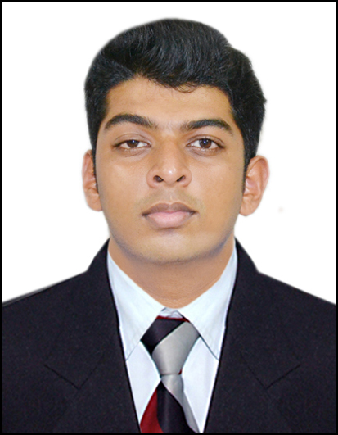
Name | : | Erran Valruss Rodrigues
Address | : | H. No. 570, Alemao Xirro, Carmona, Salcete Goa
Date of Birth | : | 18th March 1995
Marital status | : | Single
Nationality | : | Indian
Gender | : | Male
Religion | : | Roman Catholic
Mobile No. | : | 0832-2844811 / 9049627315
Email Id | : | erran18@Yahoo.in

career objective:
- I would like to work in Company which provides an environment where I can utilize my full potential and also get a chance to contribute positively towards meeting company’s objectives.

STRENGTH:
- Sincerity and perseverance are integral part of my character, coupled with a sound intellect
- Ready to undergo any kind of training and transformation to enhance professional skills.
- Ability to work hard with smartness and also having positive attitude towards my work.

Educational Qualification:
Degree | Name of  University/  Board | Performance  Year
Secondary School Certificate | Goa Secondary Education Board | March – 2010
Higher Secondary School Certificate | Goa Higher Secondary Education Board | March – 2012
Bachelor of Computer Applications | Goa University | April - 2015

TECHNICAL QUALIFICATION:
Course | Duration
Comptia A+ (professional hardware course) | 6th july 2015 – 5th Sept 2015
MCSA (Microsoft Certified Solutions Associate) | 31st august 2015 – 30th October 2015
CCNA (Cisco Certified Network Associate) | 2nd Nov 2015 – 11th Dec 2015

EUROPEAN BARTENDER SCHOOL :

- Completed International Bartender Course
- Knowledge of 72+ Cocktails
- Knowledge of different types of garnishes
- knowledge of bar cleanliness & Hygiene
- Commodity handling
- Bar setup
- Working as a Team
- Drink mixing techniques
- Serving techniques
- Free pouring with accuracy
- Working with Exhibition Flair
- Knowledge of different Spirits, Beer, Wine

Languages Known :
- English
- Hindi
- Konkani

Personal Competencies:
- Ability to work in a fast-paced environment to set deadlines
- Enthusiastic self-starter who contributes well to the team
- Work according to the Companies Policies

Other Skills:
- Professional Martial Arts Student
- Passion for Bodybuilding

Hobbies:
- Badminton
- Volleyball
- Marital arts
- BodyBuilding

Achievements:
- Participated and won at school events
- Participated and won at higher secondary events
- Obtained Gold 2 times at Goa University for Taekwondo
- Obtained Bronze 1 time at all Goa taekwondo
- Organized National level College Tech Fest “NOESIS” for 3 Years
- Won at University Events

Erran valruss rodrigues

