
Mahmoud Ismail Ahmed

DUBAI (UAE)

E-MAIL :

mahmoudismail1985@yahoo.com

Telephone : +971555231067

PROFILE

As a dynamic personality with more than eleven years of professional experience in hospitality industry. I have been tenacious in foreign strong relationship with all internal and external customers and have built up a reputation for unwavering credulities, Loyalty and accuracy. I am motivated, hard working, reliable and productive person having the confident to face the challenge in a result oriented manner.

CORE COMPETENCIES

- Strong team player having a flair for interactive group activities
- Posse’s strong Leadership qualities, inspiring other towards shared goals.
- Ability to work under pressure ad handle difficult situation with confidence.
- Ability to consistently deliver good result
- Dubai driving license valid tell 05/12/2021

PERSONAL DETAILS

PERMANENT ADDRESS : Tecom, Dubai
DATE OF BIRTH : 25th January 1985
MARITALSTATUS : Married
NATIONALITY : Egypt
PASS PORT NO. : A13322837
DATE OF ISSUE : 11/10/2014
DATE OF EXPIRY : 10/10/2021
Language : Arabic, English, basic French

PROFESSIONAL AND ACADEMIC QUALIFICATION

- Secondary modern school Egypt 1997
- High school tabary Sheraton 2001/2002
- Technical institute of commercial 2007

WORK EXPERIENCE

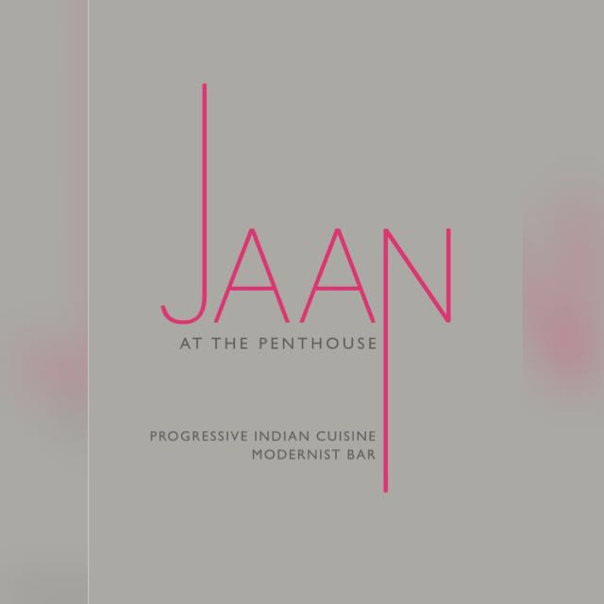 JAAN AT THE PENTHOUSE May 2016 – Present

Restaurant Supervisor

- Reporting to Restaurant Manager
- Lead 25 team members
- Guiding Pre opening service training session
- Assist in new menu implementation
- Consistently review operations and staff to identify any problems, opportunities to improvement
- Scheduling
- Dealing with guests feedbacks

 CAVALLI CAFFE DUBAI Nov 2014 – Apr 2016

Restaurant Supervisor

- Reporting to Restaurant manager
- Guide team of 20 members (including BOH)
- Participated in pre opening and opening phase of caffe including trainings and trial services
- Lead trainings (brand standards, vision, SOP, product knowledge)
- Supervising Catering functions and special events
- Strongly involved with POS system, cashing up, log reports

 OKKU RESTAURANT DUBAI Apr 2012 - Oct 2014

Team leader

- Reporting to Restaurant Manager
- Lead 6 team members
- Promoted from Head Waiter to Captain position
- Handle cashiering and reports of service periods
 AMIKA CLUB DUBAI Apr 2011 - March 2012

Restaurant Captain

- Reporting to Restaurant Manager
- Guiding assigned outlet section
- Coordinate 4 team members during service
- Participated in various trainings

 MEDIA ONE HOTEL_DUBAI Feb 2009 – Jan 2011

Restaurant Head waiter Pre opening team

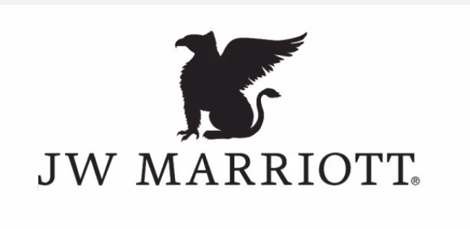 JW MARRIOTT HOTEL CAIRO Sept 2008 – Jan 2009

Restaurant Team leader

 CONCORDE HOTEL CAIRO Nov 2005 – Aug 2008

Waiter Promotion to Senior Waiter

AWARDS ACHIEVMENT & SEMINARS ATTENDED

- Foundation Certificated in Food Hygiene from Chartered instate of Environmental Health on December 2009. Dubai (U.A.E.) certificate.
- Successfully completed Fire safety awareness training from first security group Dubai (U.A.E.) on January 2010.
- Appreciation letter From JW Marriott

Successfully completed the following training courses:-

  - Decision Customer service Extra Miles on 2009
  - Making Course on Sep 2009
  - First Aid course on October 2009

