Muhammad Zeeshan
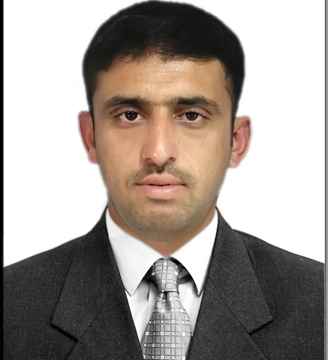
Applying For : Licence Catagory 1
Religion: Islam
Nationality: Pakistani
D.O.B.: 1st March 1998
Location: Dubai, United Arab Emirates
Mobile: +971.50.1147639
Email: xee098@gmail.com
Marital Status: Single

OBJECTIVE
To obtain a suitable position in your organization that would give me an opportunity to use my skills, experience & great sense of responsibility that assures to make positive contribution in the personal & organizational behavior

EDUCATION
Government College of Technology, Nowshera, (KPK)
Diploma of Associate Engineer in ELECTRICAL

Government college of technology, Nowshera< (KPK)
Diploma of Information Technology ( 1 Year)

LICENCE
Licence category 1. ( Motor Bike )
Place of issue: DUBAI
Date of issue: 4th OCT 2019

Licence ( Motor Car, Motor Bike )
Place of issue: NOWSHERA, PAKISTAN

Ride bike for almost 10 years in my home country. Have safe driving skills.

LANGUAGES
English, Pashto, Urdu

SKILLS
MS Word, MS Power point, MS Excel, Browsing,

EXPERIENCE
Worked in a friendly environment in a retail shop for more than 2years as a customer care and a Cashier

INTEREST
Travelling, GYM, Learning,

DECLARATION
I Hereby declare that the above statement are true and best of my knowledge

