RESUME

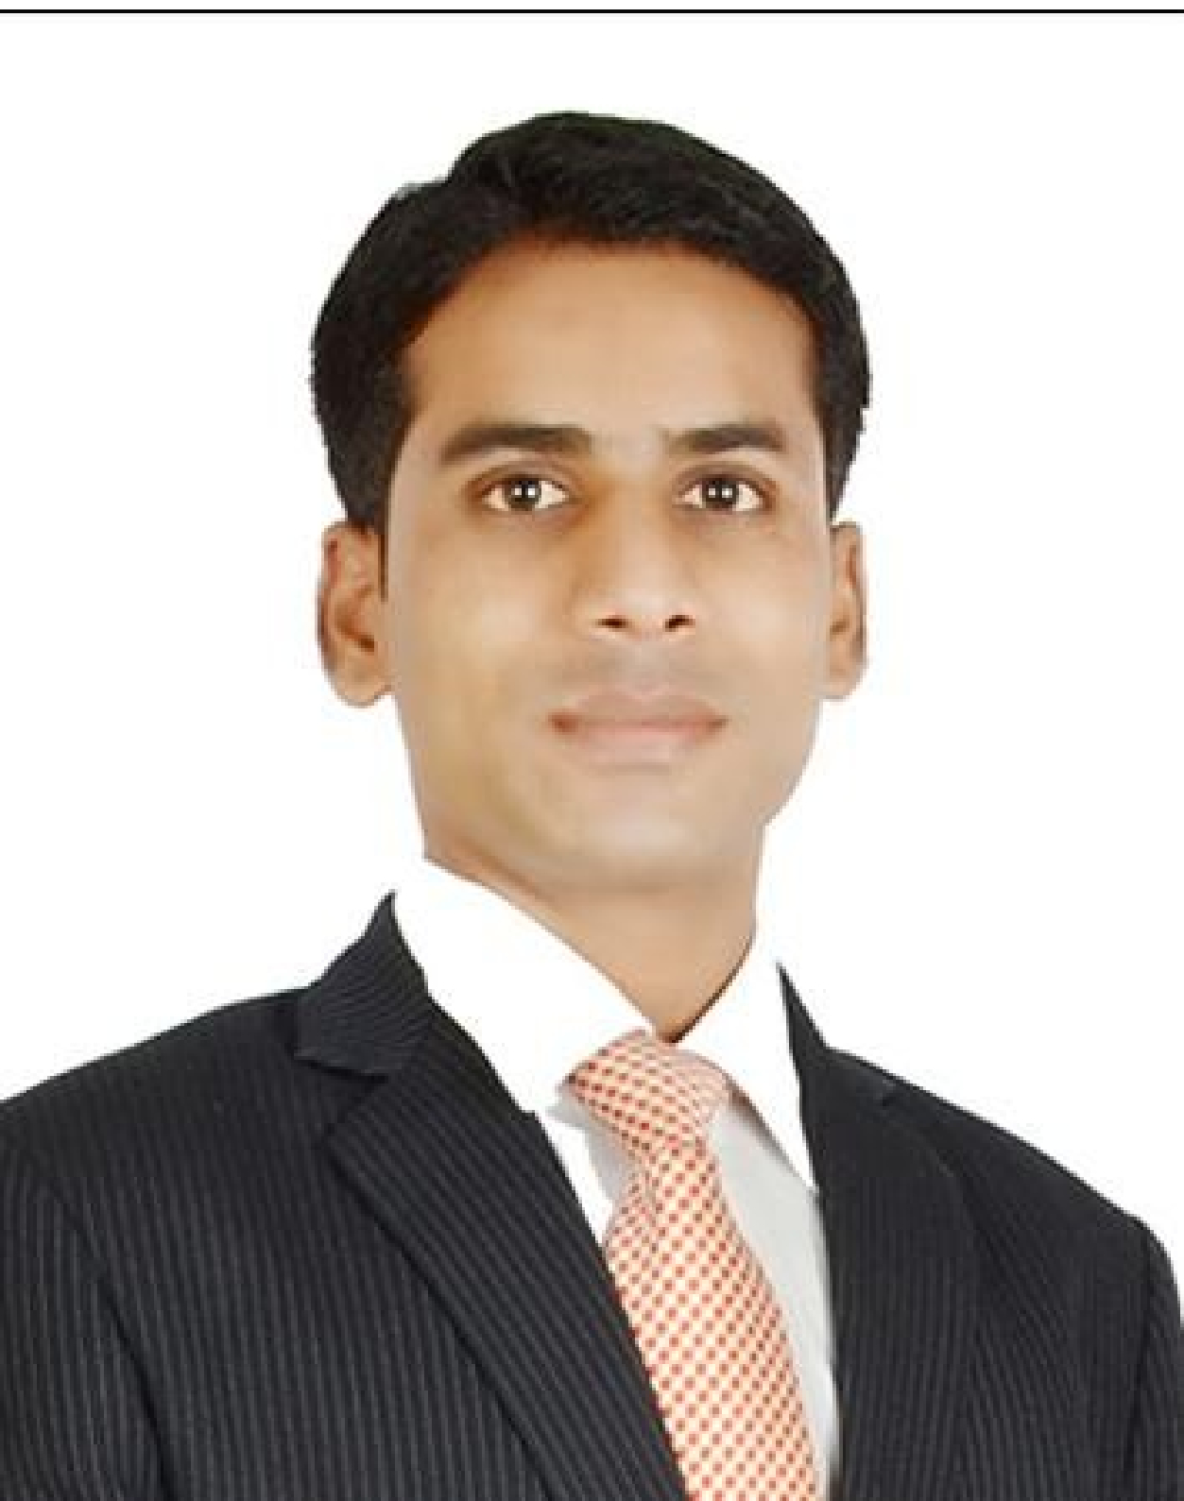
Name : Anil Bhore
Address : House No. 80,
Kawadgaon, Jamkhed,
A.nagar MH, India 413201

Cell : 91 9623046744
Email Address : bhorea228@gmail.com
Age : 28 years
Passport no : M0139253
Skype ID : anilbhore1

Career Objective
To attain the position of ‘A Bartender/ Waiter’ in your establishment.
Career Synopsis

- A professional with an experience of 28 months as a ‘Waiter.
- Experienced versatile candidate with a unique combination of Product knowledge as well as soft skills that balance work to handle responsibilities in time and professional manner.
Professional Learning
Food and Beverage Management
In Room Dining Bar and Beverage Management Restaurant Operations
Human Resource Management
Recruitment and Selection Training and Development Attrition and Retention

Work / Internship Experience
- Have worked with ‘The Westin Pune a ‘Waiter’ during 9th Feb. 2015 to 30th Sept.2015 and during 15th July 2014 to 15th Jan 2015 on contract basis.

- Have worked with Sofitel Dubai Downtown as a ‘Waiter’ from 21st Jan. 2016 to 24th Feb. 2017
Designation (Dept) | Waiter- Bar | Food and Beverage Service
Key Responsibility Areas | - Responsible for cleanliness of the station and check and keep ready all necessary equipments. Correct set-up for service. Maximizing Guest’s experience by going extra mile and being personal.  - Anticipate in guest needs, to pay attention to details, possess positive attitude and be guest focused as well as enthusiastic.  - .To relieve Team Leader and handle his KRA’s during his absenteeism including taking Food and Beverage orders by using upselling as well as suggestive selling technics and placing them on Opera, taking follow up with kitchen and make sure whether everything is as per the hotel’s standard, to take follow up of the food and service satisfaction with the guest and get the clearance done, FIFO based storage of the things, Beverage inventory, requisition, HACCP implementation, Guest Complaint handling.
Company Name | Guru Education India Pvt. Ltd.

Designation (Dept) | Communication and Soft Skills Trainer
Duration | From:01st January 2011 | To: 30th July 2013
Key Responsibility Areas | - To teach English as a subject as well as language to the trainees who were from 7th standard to post graduation.  - Have been visiting faculty to two engineering colleges for ‘Soft Skills Training’.  - To teach and revise the sessions and make trainees practice. To design the course curriculum and schedule.  - To look after admission counseling, marketing and advertising of the institution. facebook, hoardings, paper insertion and presentation at the schools and colleges.

Workshop
Workshop:
- Attended interactive session on ‘Need of Quality Professional in Corporate World’ towards to become a better professional by Mr. Sandeep Sharma Vice- President of Earth-Infrastructure.
- Revenue Management – dynamic pricing Strategies’ &’ Economic Sized Hotels Taking The Centre stage today’ by Mr. Abhishek Pasricha’ General Manager - Optus Sarovar Premiere , Gurgaon

Education
2013-2014  2007-2010 | Completed MBA in an International Hotel Management from Indian institute of Learning and Advanced Development, Haryana  Bachelor of Computer Application from Dr. B.A.M. University, Aurangabad  aaaaaaaaaaaaaaaaaaaaaaaaaaaaaaaaaaaaaaaaaaaaaaaaaaaaaaaaaaaaaaaaaaaaaaaaaaaaaaaaaaaaaaaaaad

Personal Information:
Marital Status : Unmarried

Nationality : Indian

Language Skills : Marathi, Hindi, English

Computer Skills : MS- Office

Permanent Address: House No.80, Kawadgaon, Jamkhed, A.nagar, Maharashtra. India

Postal Pincode: 413201



